**GHANA COMMUNICATION TECHNOLOGY UNIVERSITY**



**FACULTY OF COMPUTING AND INFORMATION SYSTEM**

**DEPARTMENT OF INFORMATION TECHNOLOGY**

**FOUNDATIONS OF MULTIMEDIA AND WEBSITE DEVELOPMENT**

**OSEI SOLOMON ADDO**

**(ID: 1704957112)**

**BIT EVENING**

**LEVEL 200**

**(LECTURER)**

**MR. EBENEZER AKAGLO.**

**Title Page.**

**PORTFOLIO WEBSITE DEVELOPMENT REPORT.**

PREPARED BY: [OSEI SOLOMON ADDO].

DATE: JANUARY 2ND, 2025.

Table of Contents

1. Introduction

2. Project Description

3. Features of the Portfolio Website

3.1. Navigation System

3.2. About Section

3.3. Services Section

3.4. Portfolio Section

3.5. Contact Section

4. Implementation

4.1. HTML Code Structure

4.2. CSS Styling

4.3. JavaScript Interactivity

5. Figures

6. Challenges and Solutions

7. Conclusion

8. Instructional Materials

**1. Introduction**

This document offers a detailed account of the development process for a personal portfolio website specifically designed to showcase my skills and diverse projects of myself as a UI/UX developer. It includes a comprehensive overview of the website's user-friendly features, the step-by-step implementation process that brought the design to fruition, and the challenges encountered during development. Moreover, it discusses the innovative solutions effectively applied to address these challenges, resulting in a refined and impactful final product.

**2. Project Description**

The portfolio website acts as a comprehensive digital showcase of a professional's skills, experiences, and completed projects. It features a range of interactive elements that invite user engagement, coupled with visually striking designs that capture attention. The layout is meticulously crafted to be responsive, ensuring that it provides an optimal viewing experience across various devices. This combination of aesthetics and functionality highlights the professional's expertise and enhances the overall user interaction with the site.

**3. Features of the Portfolio Website**

**3.1 Navigation System**

As shown in **Figure 3.1**, the navigation menu provides links to various sections, including Home, About, Services, Portfolio, and Contact. The menu also supports mobile responsiveness with a toggle feature for small screens.

**3.2 About Section**

The About section introduces the developer, detailing their experience and skills. Tabs allow users to explore the developer's skills, education, and experience. Refer to **Figure 3.2** for the layout.

**3.3 Services Section**

The Services section highlights the developer’s offerings, including web design, app development, and UI/UX design. Each service is represented with an icon and a brief description, as seen in **Figure 3.3**.

**3.4 Portfolio Section**

This section showcases the developer’s projects. Interactive elements display project details when hovered over. See **Figure 3.4** for an example.

**3.5 Contact Section**

The Contact section provides contact details and a form for users to send inquiries. Social media links are also included for broader reach. Refer to **Figure 3.5**.

**4. Implementation**

**4.1 HTML Code Structure**

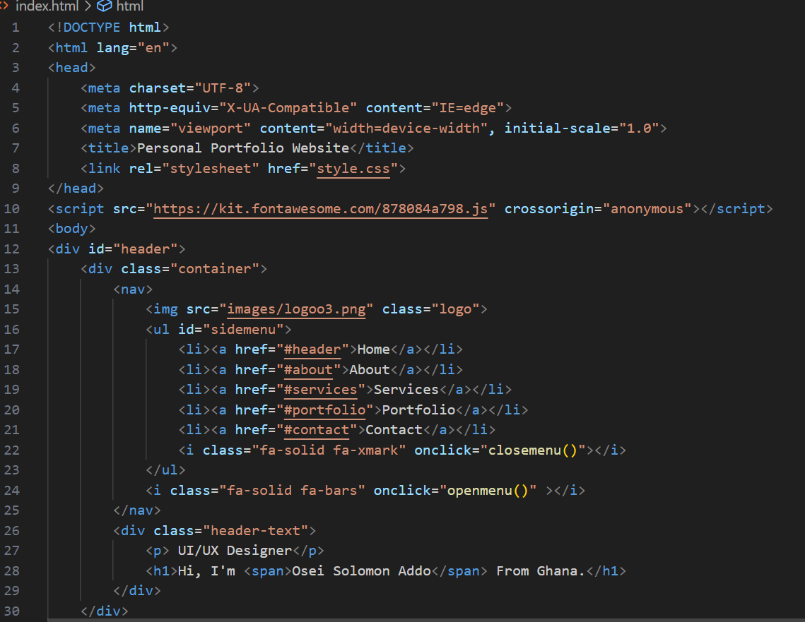

The website's HTML structure is organized into sections for clarity. Tags such as <div>, <h1>, and <ul> are used for layout and content organization.

**4.2 CSS Styling**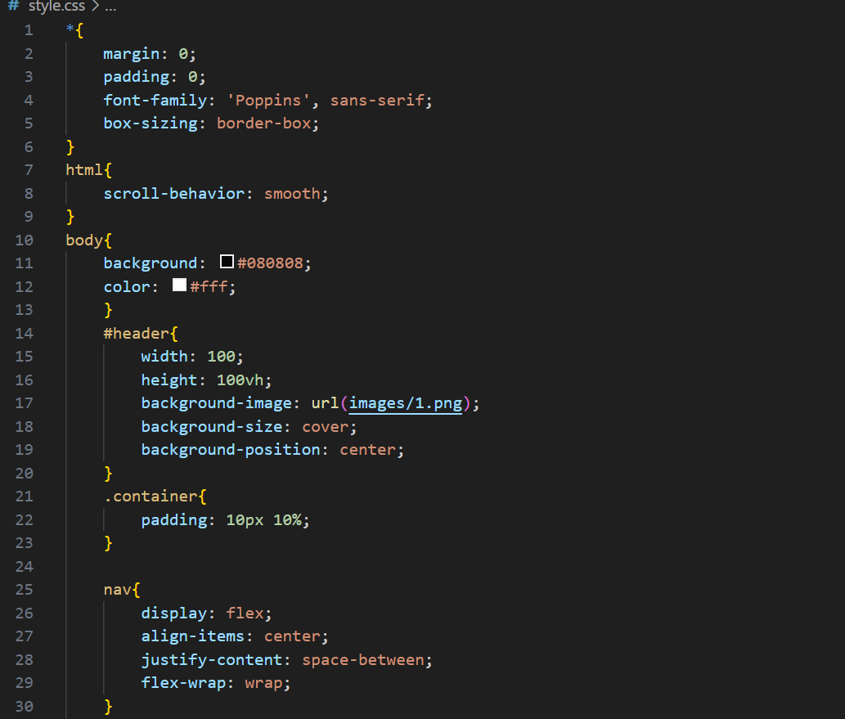

Styling is achieved using a separate CSS file. Features include responsive design, hover effects, and grid layouts to enhance visual appeal.

**4.3 JavaScript Interactivity**

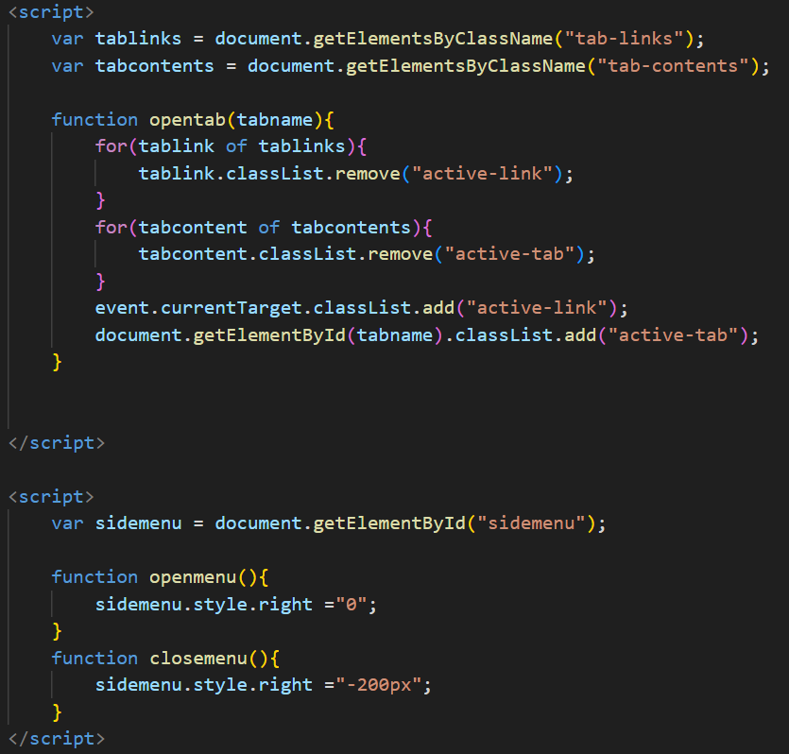

JavaScript is used for interactivity, including tab switching and menu toggling. These scripts enhance usability and provide a dynamic experience for the user.

**5. Figures.**

**Figure 3.1. Navigation Menu**

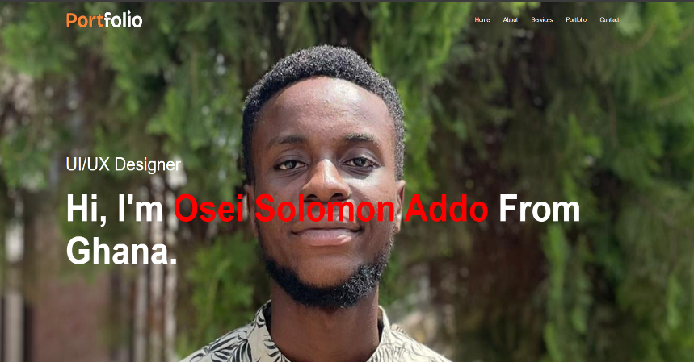

**Figure 3.2. About Section Layout**

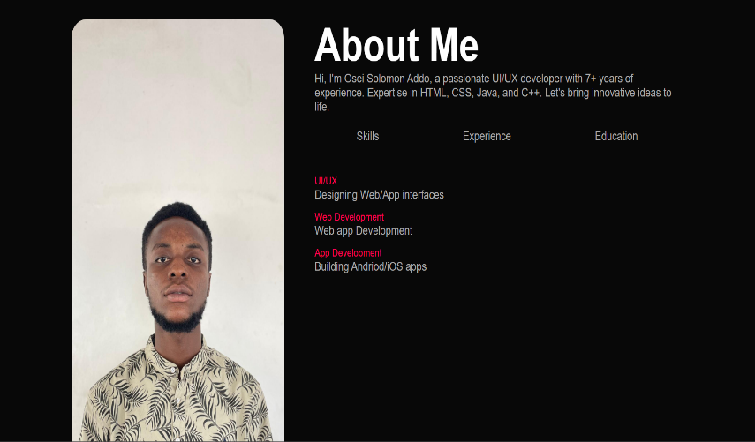

**Figure 3.3. Services Section**

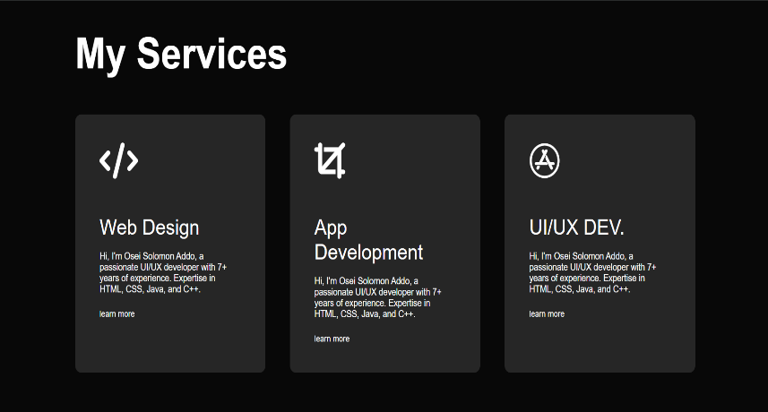

**Figure 3.4. Portfolio Section**

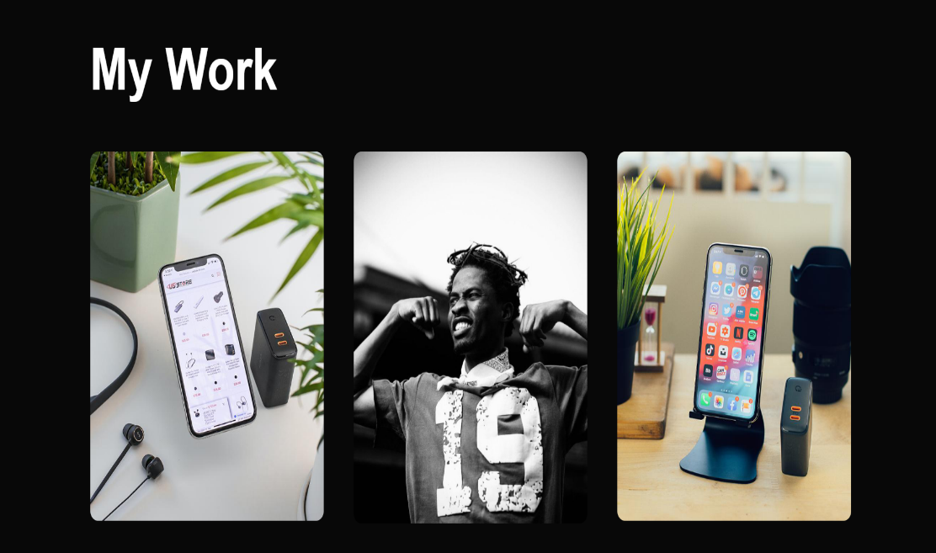

**Figure 3.5. Contact Section**

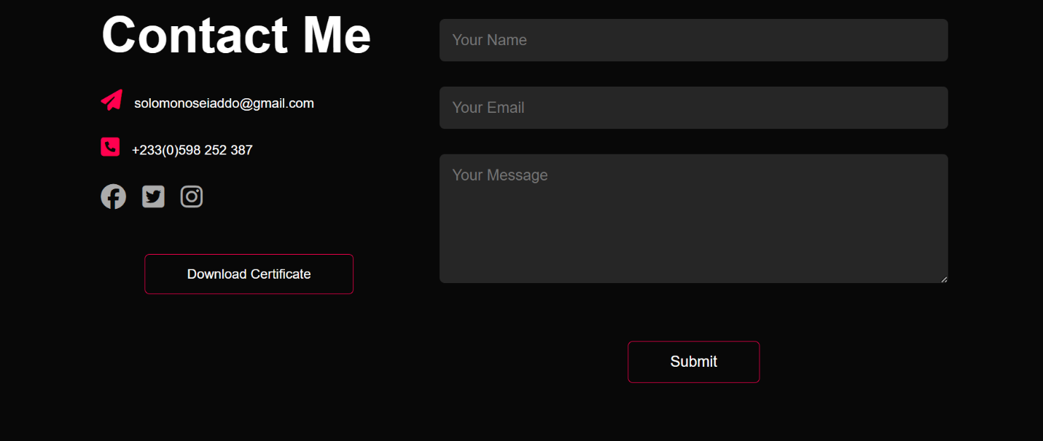

**6. Challenges and Solutions**

**Challenge 1: Responsive Design**

The navigation menu did not display correctly on small screens.

**Solution**: Used media queries to adjust the layout for smaller devices.

**Challenge 2: Hover Effects**

Hover effects did not initially work on all browsers. **Solution**: Updated the CSS code for cross-browser compatibility.

**7. Conclusion**

The portfolio website successfully meets the project requirements, offering a user-friendly and aesthetically pleasing platform for showcasing the developer’s work. Further enhancements can include additional interactivity and integrations.

**8. Instructional Materials**

**How to Run the Code**

1. Download the HTML, CSS, and JavaScript files.
2. Save them in the same directory.
3. Open the HTML file in any web browser.

**Files Included**

1. HTML file: index.html
2. CSS file: style.css

**Additional Resources**

* [W3Schools HTML Tutorial](https://www.w3schools.com/html/)
* [CSS Tricks Guide](https://css-tricks.com/)